Lindsay Kastner

**Exposure Disease Model:**

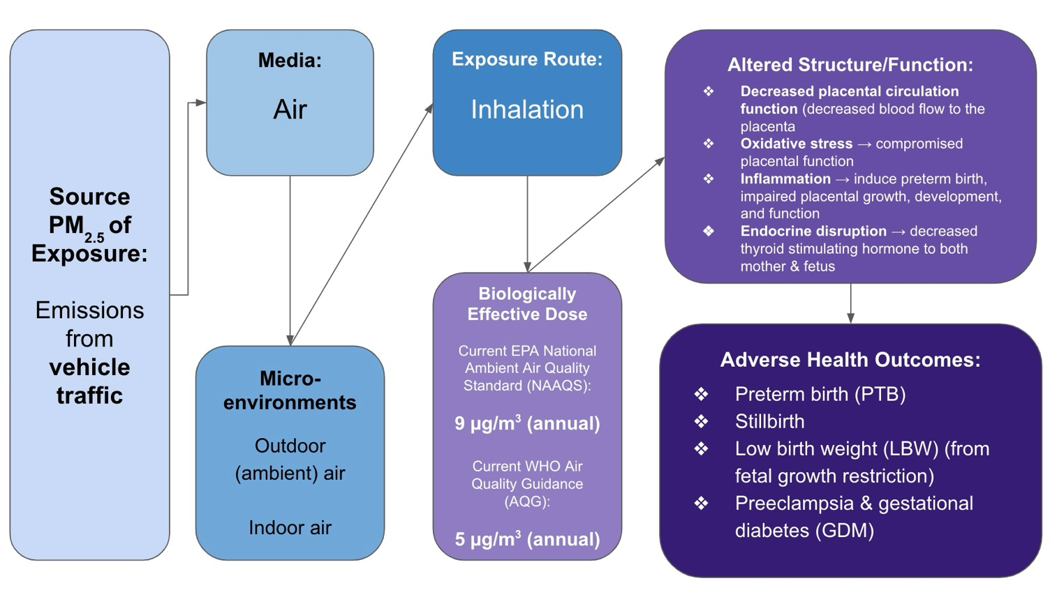

**Summary of Epidemiological Evidence for the Prevalence of and Disparities in Adverse Pregnancy Outcomes Related to PM2.5 Exposure and the Need for Increased Education and Policy Prevention**

In the past two decades, the body of literature on the linkages between ambient air pollution and adverse pregnancy outcomes has grown exponentially. The biological pathways for how and why ultrafine particulate matter (PM2.5) effects the respiratory and cardiovascular systems have been studied since the late 1990s, but a gap in reproductive effects existed until more robust evidence for reproductive toxicity emerging in the last decade or so.1 While Boston, Massachusetts has robust data collection efforts for air pollution and maintains traffic pollution that is under annual National Ambient Air Quality Standards (NAAQS),2 large disparities in exposure patterns exist for Asian, Hispanic, and Black populations in the city,3 both in terms of air pollution exposure4 *and* maternal birth outcomes.5

In a case-control study conducted in 2009 by Vera et. al, the association between exposure to particulate matter and its constituents (heavy metals and other substances) from vehicle traffic and adverse reproductive outcomes, including measures of fertility and significant reductions in birth weight.6 In a large case-control study conducted by researchers in Los Angeles, California in 2007 demonstrated that exposure to PM2.5 at high levels during the first trimester increased the odds of preterm birth in a range of 21-25%.7 More trimester-specific evidence was gathered in a Connecticut- and Massachusetts-based study conducted by Bell at. al also in 2007. In both linear and logistic regression models, PM2.5 was found to be associated with a 14.7 gram (-17.1 to -12.3, p < 0.001) decrease in birth weight per interquartile increase in pollution for the gestational period and 5.4% (p < 0.05) increased odds of low birthweight (under 2,500 grams), respectively.8

While these early studies demonstrated the linkage between PM2.5 exposure and adverse birth outcomes, the toxicological mechanisms of these outcomes were misunderstood until the 2010s. In a study published in 2015 by Kim et. al, PM2.5-induced oxidative stress and PM2.5-accelerated production of reactive oxygen species was elucidated using human cell analysis in a laboratory setting.9 Not only did the researchers find increased oxidative stress in the presence of PM2.5, but microinjection of PM2.5 into embryos caused severe mortality and impaired skeletal development.9

More recent toxicological and epidemiological evidence has refined our understanding of the reproductive effects induced by oxidative stress and the sensitive windows during gestation for PM2.5 exposure. A 2023 study conducted using participants enrolled in the Rhode Island Child Health Study (RICHS) found that increase in maternal PM2.5 exposure (at an average level of 8µg/m3) between 12 weeks before conception and 13 weeks’ gestation had a significant inverse association with female infant birthweight percentiles (-7.40 [-14.78, -0.03]) suggesting that exposure in the early prenatal period may impact implantation and maternal blood flow mechanisms associated with birth weight.10 Second and third trimester maternal exposures to PM2.5 are also thought to contribute significantly to low birthweight through mechanisms such as maternal pulmonary inflammation and placental inflammation, both of which can reduce oxygen and nutrition exchange to the fetus.11 In addition, due to the variations in PM2.5 constituents, metals and polycyclic airol hydrocarbons (PAHs) can enter the maternal bloodstream and cause DNA damage to the fetus.11

Aside from the aforementioned New England-based epidemiologic studies on PM2.5 exposure and adverse pregnancy outcomes, Boston’s urban setting, air pollution and maternal health statistics warrant improved maternal health education and policies. The latest *Health of Boston*: *Maternal and Infant Health Report* published in 2023 by the Boston Public Health Commission reported that the rate of LBW for Black infants (13.4%) was twice that of White infants (6.2%), and the percentage of PTB for Black mothers (13.8) was also double that of White mothers (7.1%).5 Additionally, neighborhoods with higher percentages of Black residents, including Mattapan and Dorchester, had the highest percentages of LBW for 2019, 2020, and 2021 combined at 11.8% and 11.3%, respectively.5 While these outcomes surely have multiple socioeconomic drivers, corresponding disparities in air quality over the last decade raise concerns about the possible effects PM2.5 may be having on maternal health. A fact sheet released by the Union of Concerned Scientists in 2019 entitled “Inequitable Exposure to Air Pollution from Vehicles in Massachusetts” modeled PM2.5 pollution by census tract combined with demographic information. Their findings indicated that major racial disparities in pollution patterns exist, as higher PM2.5 concentrations were higher for Asian (+36%), Black (+34%), and Hispanic (+26%) Americans than their white counterparts.3

The current EPA NAAQS for PM2.5 is 9 µg/m3,12 which is above the annual average PM2.5 concentration (7 µg/m3) reported in the Massachusetts 2023 Air Quality Report.2 However, the Air Quality Guidance (AQG) for annual PM2.5 concentrations from the World Health Organization is currently 5 µg/m3, supporting the epidemiologic evidence that has found adverse health outcomes at chronic, low-level exposure to PM2.5.13 Evidence using 2000 and 2010 census data suggests that non-Hispanic Black and urban Hispanic populations experience annual-average population-weighted PM2.5 concentrations of 8.4 µg/m3 and 13.0 ppb (or 7.3 µg/m3) in 2010, respectively.14

These disparities combined with relatively high levels of past exposure in Boston and the growing body of evidence of the relationship between PM2.5 exposure and adverse pregnancy outcomes suggests a gap in the current guidance given during the prenatal period to pregnant individuals in Boston, MA. Currently, Boston Public Health Commission’s resources for maternal health include programs such as Healthy Baby Healthy Child, but this program focuses more on socioeconomic vulnerabilities and parental support.15 The Mayor’s Office of Women’s Health also provides a potential home for resources on environmental exposures during pregnancy, especially in sections like “Healthy Pregnancy & Birth”.16 With two potential locations for resources on PM2.5 (and generally, vehicle traffic) exposure during pregnancy, especially focused on racial disparities, the Boston Public Health Commission and Mayor Wu’s Office of Women’s Health represent two major avenues to increasing awareness and personal efforts to reduce PM2.5 exposure during pregnancy.

References

1. Thangavel P, Park D, Lee YC. Recent Insights into Particulate Matter (PM2.5)-Mediated Toxicity in Humans: An Overview. *Int J Environ Res Public Health*. 2022;19(12):7511. doi:[10.3390/ijerph19127511](https://doi.org/10.3390/ijerph19127511)

2. Massachusetts Department of Environmental Protection. Massachusetts 2023 Air Quality Report. Published September 2024. Accessed February 28, 2025. <https://www.mass.gov/doc/2023-annual-air-quality-report/download>

**3. Union of Concerned Scientists.** Inequitable Exposure to Air Pollution from Vehicles in Massachusetts. Published May 2020. Accessed February 28, 2025. <https://www.ucsusa.org/sites/default/files/2020-05/inequitable-exposure-to-vehicle-pollution-ma.pdf>

4. Rosofsky A, Levy JI, Zanobetti A, Janulewicz P, Fabian MP. Temporal trends in air pollution exposure inequality in Massachusetts. *Environmental Research*. 2018;161:76-86. doi:[10.1016/j.envres.2017.10.028](https://doi.org/10.1016/j.envres.2017.10.028)

5. Ojikutu B. THE MATERNAL AND INFANT HEALTH REPORT. Published online 2023. Accessed February 28, 2025. <https://www.boston.gov/sites/default/files/file/2023/10/HOB_2023_Maternal_Infant_Final_Oct3.pdf>

6. Veras MM, Damaceno-Rodrigues NR, Guimarães Silva RM, et al. Chronic exposure to fine particulate matter emitted by traffic affects reproductive and fetal outcomes in mice. *Environmental Research*. 2009;109(5):536-543. doi:[10.1016/j.envres.2009.03.006](https://doi.org/10.1016/j.envres.2009.03.006)

7. Ritz B, Wilhelm M, Hoggatt KJ, Ghosh JKC. Ambient air pollution and preterm birth in the environment and pregnancy outcomes study at the University of California, Los Angeles. *Am J Epidemiol*. 2007;166(9):1045-1052. doi:[10.1093/aje/kwm181](https://doi.org/10.1093/aje/kwm181)

8. Bell ML, Ebisu K, Belanger K. Ambient air pollution and low birth weight in Connecticut and Massachusetts. *Environ Health Perspect*. 2007;115(7):1118-1124. doi:[10.1289/ehp.9759](https://doi.org/10.1289/ehp.9759)

9. Kim JY, Lee EY, Choi I, Kim J, Cho KH. Effects of the Particulate Matter2.5 (PM2.5) on Lipoprotein Metabolism, Uptake and Degradation, and Embryo Toxicity. *Molecules and Cells*. 2015;38(12):1096-1104. doi:[10.14348/molcells.2015.0194](https://doi.org/10.14348/molcells.2015.0194)

10. Deyssenroth MA, Rosa MJ, Eliot MN, et al. Placental gene networks at the interface between maternal PM2.5 exposure early in gestation and reduced infant birthweight. *Environ Res*. 2021;199:111342. doi:[10.1016/j.envres.2021.111342](https://doi.org/10.1016/j.envres.2021.111342)

11. Sun X, Luo X, Zhao C, et al. The associations between birth weight and exposure to fine particulate matter (PM2.5) and its chemical constituents during pregnancy: A meta-analysis. *Environmental Pollution*. 2016;211:38-47. doi:[10.1016/j.envpol.2015.12.022](https://doi.org/10.1016/j.envpol.2015.12.022)

12. US EPA O. National Ambient Air Quality Standards (NAAQS) for PM. April 13, 2020. Accessed February 27, 2025. <https://www.epa.gov/pm-pollution/national-ambient-air-quality-standards-naaqs-pm>

**13. Agency for Toxic Substances and Disease Registry.** ATSDR Particulate Matter Guidance. Published April 2023. Accessed February 28, 2025. <https://www.atsdr.cdc.gov/pha-guidance/resources/ATSDR-Particulate-Matter-Guidance-508.pdf>

14. Rosofsky A, Levy JI, Zanobetti A, Janulewicz P, Fabian MP. Temporal trends in air pollution exposure inequality in Massachusetts. *Environmental Research*. 2018;161:76-86. doi:[10.1016/j.envres.2017.10.028](https://doi.org/10.1016/j.envres.2017.10.028)

15. Healthy Baby Healthy Child | Boston.gov. April 26, 2021. Accessed February 28, 2025. <https://www.boston.gov/government/cabinets/boston-public-health-commission/childrens-and-newborn-health/healthy-baby-healthy-child>

16. Women’s Health | Boston.gov. February 7, 2023. Accessed February 28, 2025. <https://www.boston.gov/equity-and-inclusion/womens-health>